

Terry Follmer, Chief Audit Executive

Distribution List:
Capital Metro Board of Directors
Dottie Watkins, President & CEO
Kerri Butcher, Deputy CEO
Donna Simmons, EVP, Administration
Sharmila Mukherjee, EVP, Chief Strategic Planning & Development Officer
Catherine Walker, EVP, Chief Financial & Risk Officer
Andrew Skabowski, EVP & Chief Operating Officer
Dave Kubicek, EVP Capital Construction, Engineering & Design
Tanya Acevedo, SVP, Chief Information Officer
Muhammad Abdullah, VP Procurement & Chief Contracting Officer
Anita Deibert, Manager Acquisition & Contract Administrator
Terry Dudley, Contracts Administrator III
Muriel Friday, VP, Rail Operations
Scott Phebus, Finance Manager, Rail Operations
Wesley Brown, Project Manager, Rail Operations
Ken Cartwright, VP Facility Management & Capital Construction
Vincent Sandoval, Director, Real Estate & ROW
Brian Roybal, Project Manager
Shannon Gray, Manager, Real Estate & ROW
Ginney Worley, Specialist Real Estate
Brad Bowman, Chief Counsel
Ayeola Williams, Deputy Counsel
Chester Soares, Director of Enterprise Applications and Data Services
David McNiff, Manager Technology Systems
Antonio Smith, Application System Analyst II
Nadia Nahvi, Controller
Ben Hodges, Accounting Manager
Charlie Natal, Accountant II
Kendra Shelton, Program Manager, Technical Accounting
Brandi Mohler, Director, Revenue & Fares
Pablo Sandoval, Program Manager, Revenue & Fares
Robert Moreno, Manager Internal Audit

CLS Order System
Railroad Right-of-Way, RWIC, Permits & Licenses (24-08)
Contents
Executive Summary 1

Results ……………………………………………………………………………………………………………………………………………….4
- Missing Interfaces Between Systems Require Manual Workarounds
- Controls Over Delinquent Receivables Require Improvement
- Herzog Has Charged RWIC Overtime Not In Compliance with the Contract
- RWIC Hours Worked by Herzog Exceeded Hours Prepaid by Customers
- Real Estate ROW Standard Operating Procedures Have Not Been Updated
- Certificates Of Insurance Are Not Obtained For Recurring Annual License Agreements

Appendices 10
- ROW Installation Minimum Insurance Requirements
- ROW License Renewal Minimum Insurance Requirements
- RWIC Process and Data Flow
- Venn Diagram of Data in Each ROW Process
- Platinum Portal Screen for Customer ROW Requests
- Example of Standard Oracle Invoice
- Example of Oracle Generated Report Used to Identify CLS Link Customer Payments
- ROW Application and Invoice Statistics
- Potential Overbilled RWIC Overtime Hours
- Herzog Monthly Time Report & Error Examples – July 2023
- Herzog July 2023 Invoice
- AR Customer Aging Report for CLS Link Invoices – June 2024
- Account Receivable Policy FIN 109

Executive Summary
The fiscal year 2024 Audit Plan included the advisory review of the eleven Miscellaneous Revenues, one of which is the Railroad Right-of-Way (ROW), RWIC, Permits, and Licenses. ROW revenues in FY23 were $979,587 and in FY24 were $1,334,596. The audit results including the objective, scope, and conclusion are as follows.

Background
In 1986, CapMetro acquired from the City of Austin (COA) approximately 162 miles of railroad track, and track structures, right of way (ROW), and COA’s existing customers’ ROW license agreements which in most cases are perpetual licenses with automatic renewals with an annual license fee to CapMetro. The ROW is managed administratively by the Real Estate Department, operationally by the Rail Department, and the Finance Department bills all revenues through the Oracle system. The Real Estate Department manages the administrative functions for ROW which includes managing over 1,300 existing ROW contractor license agreements, though only 260 are classified as “Revenue” agreements (approx. $700K annually), and processing new ROW access requests. Most of the ROW licenses are for cables/conduit (e.g., fiber optics, telecommunications, etc.), pipes (e.g., oil, gas, water, sewage, etc.) and other structures that cross CapMetro owned territory both above ground and below ground. There are four types of ROW requests: license agreement, permit, road crossing and roadway-worker-in-charge (RWIC). Customers installing a new project within CapMetro’s ROW are required to complete a license application and provide a current certificate of insurance meeting CapMetro’s minimum coverage requirements (see Appendix A for Installation COI), and an updated COI is required as part of their annual license renewal (see Appendix B for renewal COI minimum requirements). Any customers, including license agreement holders requiring physical access to the CapMetro ROW are required to have a permit. Roadway crossings are less frequent but are typically applicable to grant access to private landowner property. Customers are required to request an RWIC employee for any projects that may occur close to the railroad track. Federal Railroad Administration and Rail Operations Department safety guidelines require that any contractor operating within twenty-five feet of the railroad track must have a dedicated RWIC employee assigned to protect the contractor while working near the railroad track. The RWIC employee is in constant contact with Rail Dispatch and notifies the contractor when trains will be traveling through the area. The CapMetro Rail Operations oversees the day-to-day operational aspects of the rail line, including assignment of RWIC employees from Herzog or Watco that ensure safety and compliance on each project. Note, Herzog RWIC employees oversee commuter ROW rail projects and Watco RWIC employees oversee freight ROW rail projects.

The right-of-way order processing and billing process involves three separate systems which are not integrated with each other and require multiple manual inputs and email communications. The starting point for all new customers and transactions is CapMetro’s ROW website page www.capmetro.org/railrow which will then take the customer to one of the CLS systems:
- Platinum portal (Platinum) – customer-facing application order entry system https://cmta-platinum.clsrow.com/#/ The customer enters all of their information and requests into the CLS Platinum portal.
- Contract Land System Link (CLS Link) – ROW system for managing license agreements, permits, and RWIC projects. Because the CLS Platinum is not interfaced to the CLS portal a CapMetro Real Estate employee must rekey a subset of the original data from Platinum into the CLS Link in order to create the actual customer order which is interfaced with Oracle. Note, for new customers, the new account must be manually created in Oracle first and then Oracle customer # is manually keyed into CLS Link.
- Oracle – financial system used for invoicing and collections.

The Contract Land Staffing LLC (CLS) company https://contractlandstaff.com/ - provides both the Platinum portal and the CLS Link systems that run on a CLS cloud but are not interfaced to each other, and annual ROW revenues are approximately $1M annually which are billed in Oracle. CLS is an independent right-of-way and land services company providing service solutions since 1985, and CLS Link is their technology solution for land and asset management.
Customers initiate their ROW access request on CapMetro’s website using the Platinum portal application online at www.capmetro.org/railrow. See example of process flowchart at Appendix C and Platinum portal ROW application screen at Appendix E. For new customers, the Real Estate Specialist uses the customer populated demographic details entered in Platinum and emails the information to the AR Accountant to create a customer account number in Oracle. The AR Accountant returns an email with the assigned customer number to the Real Estate Specialist who uses the customer provided project information from Platinum and the Oracle account number to manually populate the CLS Link system. Once all new CLS Link customer accounts are updated with the Oracle customer account number, the Real Estate Specialist can initiate the billing process, by creating a batch file of obligations in CLS Link. Nightly, a computer job is run in Oracle to retrieve the obligation file from CLS Link which is used to generate the customer invoice. See Appendix F for example of Oracle Invoice.

All customer fees (e.g., application; permit; RWIC; license; etc.) must be prepaid before the initial first year ROW license is granted. Note, the initial license agreements are prepaid, but there are also recurring annual license renewals that cannot be forced to be prepaid which creates a collection risk for year two and the perpetual licenses. As payments are received, they are posted to the customer account in Oracle. Oracle creates a report of the payments received, which the Real Estate Specialist manually retrieves to identify which customer payments have been received. See Appendix G for example of the report. Upon identification of payment, the customer application status is advanced for licenses or permits. For RWIC requests, the Real Estate Specialist communicates the customer project information to the Rail Operations Project Manager via email. The email includes the number of days and hours per day the customer has requested. The Rail Department PM forwards the email to the CapMetro contractor to assign an RWIC employee from either Herzog or Watco depending on if it is commuter rail line or freight rail line, respectively. For 2022, the Real Estate department had 279 new applications (Permit; RWIC, License) and 263 new applications in 2023. See details at Appendix H.

Audit Objective & Scope
The objective of the audit was to review the design and operating effectiveness of internal controls to ensure the completeness and accuracy of the ROW orders processed in the CLS systems and the billing and collections that occur in the Oracle system. The scope covered ROW orders processed for 2023 and 2024, as well as the RWIC hours billed to CapMetro from Herzog for this period.

Opinion
In our opinion, internal controls over ROW the billing and collections process require improvement in the following areas:
- Missing Interfaces Between Systems Require Manual Workarounds
- Controls Over Delinquent Receivables Require Improvement
- Herzog Has Charged RWIC Overtime Not In Compliance With The Contract
- RWIC Hours Worked by Herzog Exceeded Hours Prepaid by Customers
- Real Estate ROW Standard Operating Procedures Have Not Been Updated
- Certificates of Insurance Are Not Obtained For Recurring Annual License Agreements

More details regarding the issues/risks and recommendations can be found below in the detailed audit report.

This audit was conducted in accordance with US Government Accountability Office’s Generally Accepted Government Auditing Standards (GAGAS) and the Institute of Internal Auditor’s International Standards for the Professional Practice of Internal Auditing. These standards require that we plan and perform the audit to obtain sufficient, appropriate evidence to provide a reasonable basis for our findings and conclusions based on our audit objective. We believe the evidence obtained provides a reasonable basis for our findings and conclusions based on our audit objectives. The audit was conducted by the following staff members in the Capital Metro Internal Audit Department:
- Robert Moreno, Manager of Internal Audit
- Terry Follmer, Chief Audit Executive

Recommendations to strengthen controls and improve accountability were provided to management. Management agrees with the internal audit recommendations and has provided target completion dates which are included in the detailed audit report below. A follow-up audit is performed semi-annually (i.e., May and November) to ensure management action plans for all issued audit reports are completed in a timely manner.

We appreciate the cooperation and assistance provided to us throughout this audit.

Audit Report

Issues & Risk | Recommendation | Management Action Plan
- MISSING INTERFACES BETWEEN SYSTEMS REQUIRE MANUAL WORKAROUNDS  The right-of-way process uses two separate CLS systems for order entry that are not interfaced to each other. Customers must first enter their order into the Platinum system, and when the Real Estate Specialist sees the new customer order, she must rekey a subset of this data into a second system called CLS Link to create the actual order. More details on the business processes and data flow can be seen at Appendix C (Process Flowchart) and Appendix D (Venn diagram – data collected by system).  - ORDER ENTRY IN TWO CLS SYSTEMS - Each ROW license, permit and RWIC requests require customers to enter their customer and project information into the Platinum portal for each application. The Real Estate Specialist (RE Specialist) then accesses the Platinum system to obtain the customer information to manually key into the CLS Link system for creating the customer record and initiating the invoicing process. Additionally, AR Accountant manually keys in customer billing information obtained from Platinum into Oracle to set up customer accounts.  - BILLING & COLLECTIONS IN ORACLE - CLS Link pushes an order obligation file to Oracle to create an invoice for license, permits, and RWIC requests. Customer payments are processed in Oracle. For RWIC requests, the Real Estate Specialist runs an Oracle payments report to identify the paid RWIC requests. See report example at Appendix G. The Real Estate Specialist emails the customer RWIC project information to the Rail Operations Project Manager, who forwards the same email to the CapMetro contractor (Herzog or Watco) to schedule and assign RWIC employees to the project.  The manual processes and lack of interfaces and/or automated workflows described above increase the risk of errors, delays in processing and limits the transparency of project status since requests and confirmations are happening through emails which then have to manually input into CLS and Oracle. | Internal Audit recommends the Controller, Director of Revenues & Fares, Director of Enterprise Application & Data Services, and the Director of Real Estate and ROW evaluate the following process improvements:  a) New ROW Orders - If new orders are entered by customers into the CLS Platinum system can be interfaced to CLS Link, so that the Real Estate Specialist does not have to enter all new orders from scratch to create an order in the CLS Link system. Thus, creating a single database in the CLS Link system instead of having two separate databases in CLS Platinum and CLS Link that do not talk to each other.  b) New ROW Customers - For new customers in CLS Link, opportunities to automate the creation of new customer requests into Oracle, so that the A/R Accountant does not have to enter all data from scratch. Currently manual emails between Real Estate Specialist and AR Accountant are needed to notify each other and then manual key into CLS Link and Oracle.  c) Prepaid RWIC Hours – create workflow automation notifying Rail Operations when RWIC orders have been prepaid. Currently manual emails must be sent to Rail Operations with all details (e.g., requested RWIC dates, number of prepaid RWIC hours, milepost #, etc.). Include a closed loop in the workflow so that actual hours worked by Herzog are reported back and compared to prepaid hours. If actual RWIC hours exceed prepaid hours, include a process to create an extra billing for the extra hours worked. The revenue leak for this was $23,600. See issue #3 below. | Management agrees and has developed the action plan below.  The CLS contract will expire on 1/9/25. Management is implementing a 1-year stop-gap extension that is currently pending approval. IT will have to research, evaluate systems, strategy, and budgeting to determine and prioritize the best solution for this recommendation.  Target Completion Date:  To be determined
- CONTROLS OVER DELINQUENT RECEIVABLES REQUIRE IMPROVEMENT  The June 2024 Aged Accounts Receivable report (See Appendix L) shows past due accounts over 150 days was $531,770, with ROW related customers being $443,663 (83%), of which 51% are greater than 2 years old. We reviewed the controls over accounts receivables and collections and identified the following weaknesses:  - Policy FIN-109 Accounts Receivable (Appendix M) - is dated 1/2016 and requires updating. It does not include the following: establishing credit evaluations and limits; charging late payment fees as listed in license agreements; escalation process for past due accounts (e.g. charging interest, filing liens, canceling licenses, litigation, etc.); delegations of authority for credit limit and write-offs, notifying management of delinquent account balances.  - The Finance Department has not developed written procedures to support the Accounts Receivable Policy.  - We noted the license agreements dated 2012 and later stipulate a “late charges of 5% of the outstanding balance would be assessed on payments received 10 days after the payment due date”, however, the Finance Department has never enforced late charges and has not designed a process or system controls to make this happen.  - License agreements and invoices do not stipulate a charge for interest on delinquent accounts. (See Oracle Invoice at Appendix F).  - For some delinquent customers, the AR Accountant does not have current customer AP contact information in Oracle to send invoices which could delay A/R collection timeline.  - The Collections module was not included in the Oracle ERP system implementation.  - CapMetro does not have a process to check CapMetro ROW territory for unauthorized cables/conduit (e.g., fiber optics, telecommunications, etc.), pipes (e.g., oil, gas, water, sewage, etc.) and other structures. Real Estate management believes there are customers who have installed infrastructure on the CapMetro ROW without following the ROW process or providing any payments to CapMetro.  The weaknesses identified above increase the risk that customer accounts will not be collected timely, and accounts receivable balances will continue to grow. Unauthorized ROW pipes, cables, conduits both above ground and below ground create a liability hazard. | Internal Audit recommends that management consider the following:  a) The CFO and Controller should update FIN Policy 109 to include processes for establishing customer credit evaluations and limits, charging late fees, escalation process for past due accounts, delegations of authority for credit limits and write-offs and notifying management of delinquent account balances.  b) The CFO and Controller should develop SOPs that describe how delinquent accounts will be managed. The procedures should include frequency of customer communications, dispute resolution procedures, and establish debt collections procedures such as discontinuing new business with delinquent account customers, issuing breach of contract notices, obtaining liens, contracting with collection agencies, and account write-off or settlement procedures.  c)The CFO and Controller should consider charging the 5% fee for late payments as defined in the customer license agreement.  d) The CFO and Chief Counsel should consider modifying the standard terms and conditions listed in new license agreement contracts and on invoices to include a statement that allows late fees and interest to be charged by Capital Metro on delinquent accounts.  e) The Controller and AR Accountant should establish agreed upon procedures with the Manager of Real Estate & Right-of-Way to obtain updated customer AP contact information annually to maintain current billing information.  f) The CFO, Controller and Director of Revenue & Fares should consider implementation of the Oracle Collections module.  g) The Director of Real Estate & ROW should consider hiring a third-party consulting firm, on a consignment basis, to reconcile installed infrastructure with active CapMetro license agreements to identify any non-compliant or unauthorized infrastructure. | Management agrees and has developed the action plan below.  For items a), b), and c) Finance will update FIN Policy 109 and will develop departmental SOPs for accounts receivable. Finance will benchmark available collection options and enforcement actions used by other transit agencies and incorporate best practices into the SOPs. The SOPs will define roles and responsibilities and guidelines for collection options and enforcement actions by March 31, 2025.  d) Legal will research the regulatory requirements for placing liens, charging interest or other potential options to include in future license agreement language to strengthen the CapMetro collection position by January 31, 2025.  e) Finance will include the agreed upon procedures as part of the roles and responsibilities developed for the SOPs. March 31, 2025.  f) Finance will discuss and evaluate implementation of Oracle collections module. Date TBD  g) Real Estate Management will consider bringing in a consultant to evaluate ROW infrastructure for compliance with CapMetro standards. Legal will help Real Estate define and develop SOPs for correcting potential non-compliant or unauthorized infrastructures.  June 30, 2025.  Target Completion Date:  Multiple dates
- HERZOG HAS CHARGED RWIC OVERTIME NOT IN COMPLIANCE WITH THE CONTRACT  Herzog employees provide Roadway Worker in Charge (RWIC) services for contractors working on the CapMetro right of way. The base contract included three RWIC workers and a modification (Mod 37 signed 10/1/2020 and later Mod 56 signed 1/17/23) added 2 additional RWIC employees to bring the total to 5 designated RWIC employees. The original base contract did not allow overtime to be charged to CapMetro, but the modifications did allow overtime to be billed to CapMetro for the two new RWIC employees to CapMetro if these two Herzog employees exceeded 80 RWIC hours per week and was pre-approved by CapMetro in advance.  Our testing disclosed that Herzog billed overtime for all employees, not just those assigned to the modification. From July 2022 to July 2023, Herzog incorrectly billed for 493.5 hours of non-eligible overtime and 44 hours of overtime not assigned to any employee totaling $35,226. See summary of overbilling details at Appendix I.  In our review of the monthly Herzog RWIC invoice support for the two employees assigned to the contract modification, we found additional overtime calculation errors resulting in overbilling 303 hours of overtime ($19,729). See details at Appendix I. In some instances, Herzog billed for overtime though the employee had not worked 40 regular hours per week, or the calculation periods were misaligned to combine hours for multiple weeks in determining the excess of 40 hours. See Appendix J for the July time report and examples of errors and Appendix K for July Herzog invoice. Subsequent RWIC invoices for August 2023 through December 2023 were rejected by the Rail Department and were not paid.  Without timely reconciliations of Herzog RWIC employee weekly hours and overtime calculations, the potential errors and overbilling to CapMetro could continue. | Internal Audit recommends that the VP of Rail consider the following actions:  a) Require Herzog to create and provide an improved monthly RWIC hours worked report that contains names of the five full time RWIC employees covered in our contract, which RWIC orders they worked on and how many hours on each order, clear designation as to which three Herzog employees cannot bill CapMetro for OT, and which two Herzog employees are allowed to bill CapMetro for OT.  b) Report the Herzog overtime billing errors to the Contract Administrator in the Procurement Department and pursue a refund for the overbilled amounts of $54,955 ($35,226 + $19,729). | Management agrees and has developed the action plan below.  a) The Rail PM has received an email from Herzog identifying the employees assigned to the base contract and to Mod56. All requests for overtime for Mod56 are now sent to the Rail PM for approval via email and the approval/denial response is provided back to Herzog via email. Rail PM tracks the hours for each project individually. The Rail PM will request that Herzog provide weekly employee time reporting for all employees with approved overtime by January 31, 2025.  b) The VP of Rail will determine if Herzog has documentation authorizing any of the overtime billed by January 31, 2025. Due to the volume of overtime activity related to the McKalla Station, management has agreed to split the cost of any overtime that may not have been billed correctly. The VP of Rail will request a refund of the overtime billed by March 31, 2025. Additionally, the contract modification language will be strengthened to reduce ambiguity for the overtime requirements.  Target Completion Date:  March 31, 2025
- RWIC HOURS WORKED BY HERZOG EXCEEDED HOURS PREPAID BY CUSTOMERS  CapMetro’s policy for RWIC services is for customer requests to be made in 8- or 10-hour increments and must be prepaid, and Herzog performs the RWIC service.  We reviewed the controls related to the RWIC prepaid services and hours worked by Herzog and identified the following weaknesses:  - As noted in recommendation #1c above, there is no automated workflow for prepaid RWIC hours, so manual emails are sent by the Real Estate Specialist to Rail Operations and Herzog requesting RWIC hours.  - There is no “closed loop” process to reconcile and report RWIC prepaid hours to actual hours worked by Herzog.  - Our testing of 2022 and 2023 RWIC hours identified that actual RWIC hours exceeded prepaid hours by 236 hours resulting in lost revenues of $23,600 that were never billed.  - There are no performance metrics created manually or in the CLS Link and Oracle systems, for example: prepaid hours versus actual hours by order/invoice (over/under/equal) and any difference; date RWIC hours were requested by customer to be completed versus actual; licensee accounts missing their certificate of insurance at the annual renewal and if/when provided.  The weaknesses identified above increase the risk of extra RWIC hours worked beyond what was prepaid will not be billed; inappropriate Herzog OT hours billed to CapMetro will not be identified; problem accounts that have not provided COI and/or are delinquent will not be flagged for follow-up, and opportunities to improve customer service. | Internal Audit recommends that Management consider the following actions to reconcile RWIC hours:  a) The VP of Rail Operation should establish procedures for Herzog to notify both Rail Operations and Real Estate when the customer exceeds or expects to exceed the number of prepaid hours on a project and instruct the customer to complete a request for additional RWIC hours.  b) The VP of Rail Operations, the Director of Real Estate and ROW and the Manager of Real Estate and ROW should coordinate the completion of reconciliation procedures to ensure all RWIC charges are billed by having the Rail Operations PM compare the actual RWIC hours worked to the requested prepaid hours by project and notify Real Estate Specialist of any additional billing requirements. | Management agrees and has developed the action plan below.  a) The Rail PM will create SOPs which document the process for assigning RWIC projects to contractors. The SOPs will clarify the process for routine RWIC assignments and define responsibilities when customer requests additional hours.  b) Real Estate will update reconciliation procedures that need to be updated and will meet with the Rail department to ensure responsibilities are coordinated.  Target Completion Date:  March 31, 2025
- REAL ESTATE ROW STANDARD OPERATING PROCEDURES HAVE NOT BEEN UPDATED  On CapMetro’s website www.capmetro.org/railrow the Real Estate Department staff has developed an overview of ROW procedures for explanation of the process to customers. The annual ROW billings are approximately $1M per year across 445 orders and transactions. We reviewed the internal controls related to the ROW order processing, billing and collections and noted the following weaknesses:  - Internal written procedures need to be completed detailing how the Real Estate Specialist processes customer orders in the two CLS systems, ensures proper billing in Oracle, reviews problem accounts that are either delinquent and/or have not provided the updated annual certificate of insurance, etc.  - SOPs covering the needed reconciliation of prepaid RWIC hours to actual hours worked by Herzog/Watco have not been developed.  - SOPs for the monthly reconciliation of Herzog RWIC hours to each customer order fulfilled as well as Herzog OT hours billed to CapMetro have not been developed.  - Policy on the CapMetro website requires that all RWIC hours be ordered and prepaid in 8- or 10-hour increments, however, two contractors (Reagan National Advertising and Lamar Outdoor/Austin Crane Service), are allowed to request RWIC hours in less than 8-hour increments. We noted that there is no policy and/or procedure addressing who can approve exceptions and which departments and personnel should be notified of any exemptions.  - The process documentation references the prior Microsoft Dynamics AX system and has not been updated to reflect the implementation of the Oracle system.  Lack of current documentation can lead to inconsistent and/or unauthorized procedures being followed. | Internal Audit recommends the Director of Real Estate & ROW, and the Manager of Real Estate & ROW should consider updating the ROW procedures document for changes to be consistent with the Oracle system and to formalize any approved exceptions to the standard procedures. | Management agrees and has developed the action plan below.  SOPs will be updated and will incorporate any changes required by a potential new system implementation.  Target Completion Date:  May 31, 2025
- CERTIFICATES OF INSURANCE ARE NOT OBTAINED FOR RECURRING ANNUAL LICENSE AGREEMENTS  Customers requiring access to the CapMetro right-of-way (ROW) to install infrastructure (e.g., pipelines, underground pipelines or fiber optic cables or overhead telecom lines) must provide proof of insurance via a certificate of insurance (COI) before installing the equipment and annually thereafter as part of the annual license renewal process. Real Estate currently manages over 1300 license agreements. We reviewed the internal controls over COIs on new licenses as well as renewals and noted the following weaknesses:  - We sampled five ROW licenses for year one and noted one COI could not be located for year one, and all five license agreements were missing COIs for the outgoing years.  - There is no SOP related to COIs and no one from the Real Estate department is requesting and/or obtaining COIs as part of the perpetual license renewal process. There is no request for customers to provide valid COIs on the license agreement anniversary date.  - The CapMetro website does not mention the requirements for the customer to provide a valid COI with the minimum coverage levels, however, each individual license contract does specify the minimum required COI insurance amounts to be provided annually.  The weaknesses noted above increase the risk that proper insurance is not being obtained to protect CapMetro in the event of a liability event. | Internal Audit recommends that the Director of Real Estate & ROW consider the following:  a) SOPs will be developed covering activities to ensure initial COI is obtained as well as annual COI updates as part of the license renewal process. Protocols will be developed as to how to manage customers who refuse to provide annual COI’s and/or have deficiencies in the insurance limits provided.  b) The CapMetro website will be updated to explain COI requirements for the customer in year one as well as the annual COIs as part of the perpetual renewal process.  c) All active license accounts will be reviewed, and customers will be notified of any missing COIs or deficiencies in insurance coverage amounts. COI records either online in CLS Link and/or Oracle and/or manual records will be developed tracking COIs for each active license account going forward. | Management agrees and has developed the action plan below.  a) Real Estate Management will work with Finance to add the request for COI to the annual customer invoices.  b) Real Estate Management will work with Marketing to add COI requirements to the CapMetro website.  c) Real Estate Management will seek temporary resources to identify the backlog of customers without current COIs and will request an updated COI. Documentation obtained will be loaded into CLS.  Target Completion Date:  May 31,2025

Appendix A

ROW Installation Minimum Insurance Requirements

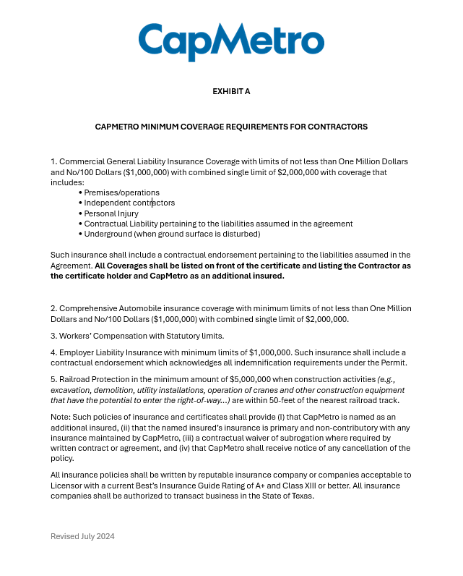

Appendix B

ROW License Renewal Minimum Insurance Requirements

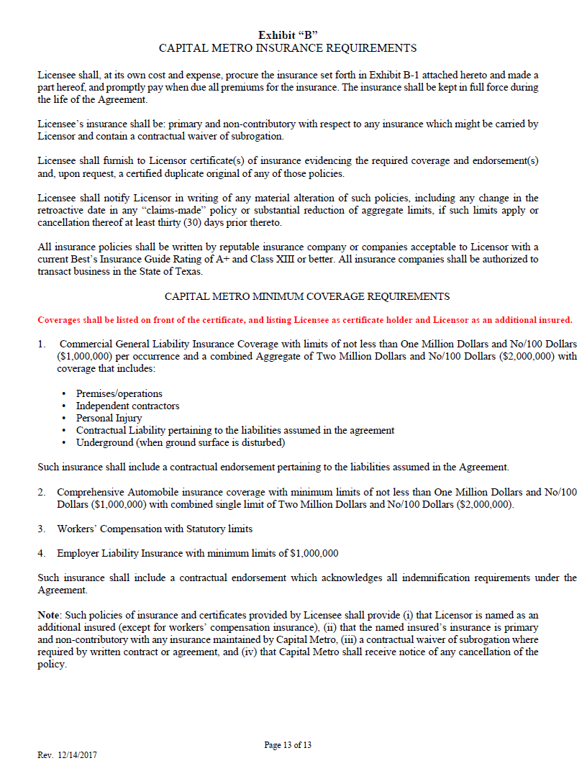

Appendix C

RWIC Process and Data Flow

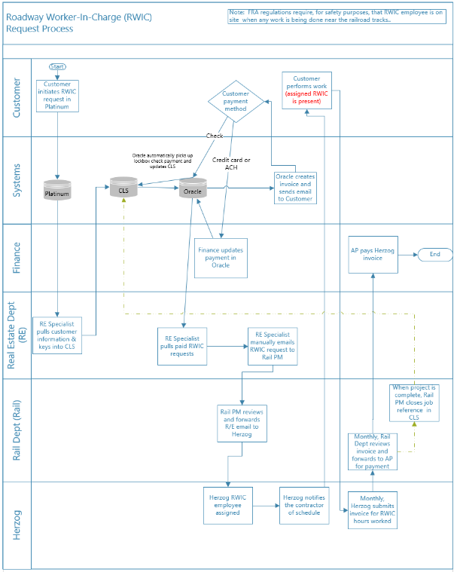
Note: Flowchart assumes ROW License and Permit have been obtained.

Appendix D
Venn Diagram of Data in Each ROW Process

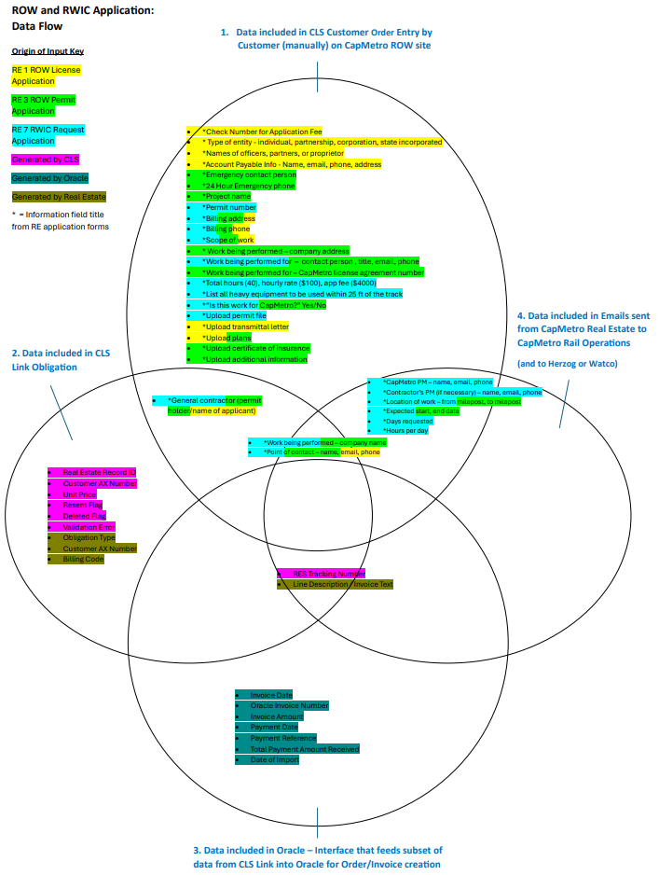

Appendix E
Platinum Portal Screen for Customer Requests

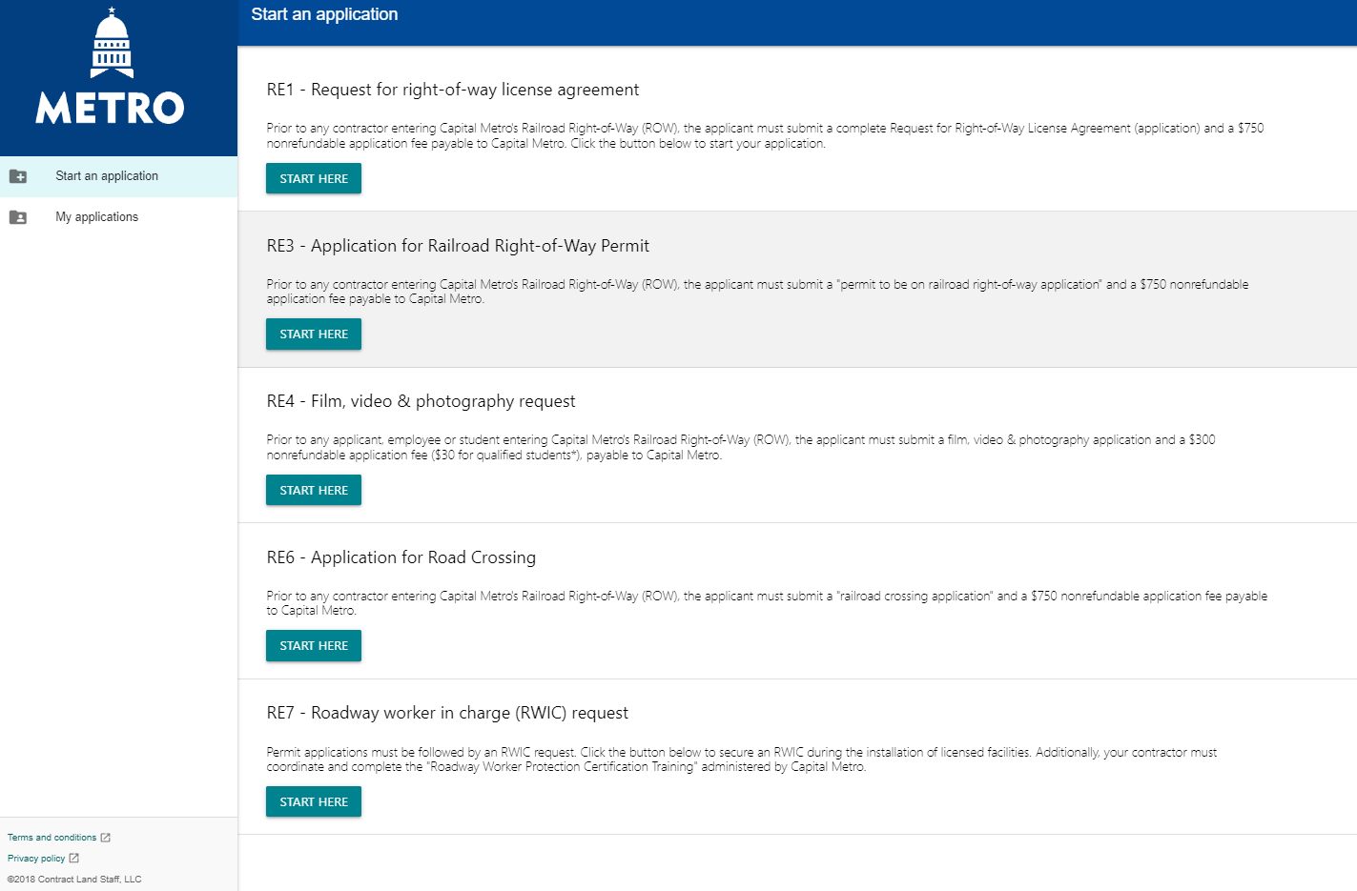

Appendix F
Example of Standard Oracle Invoice

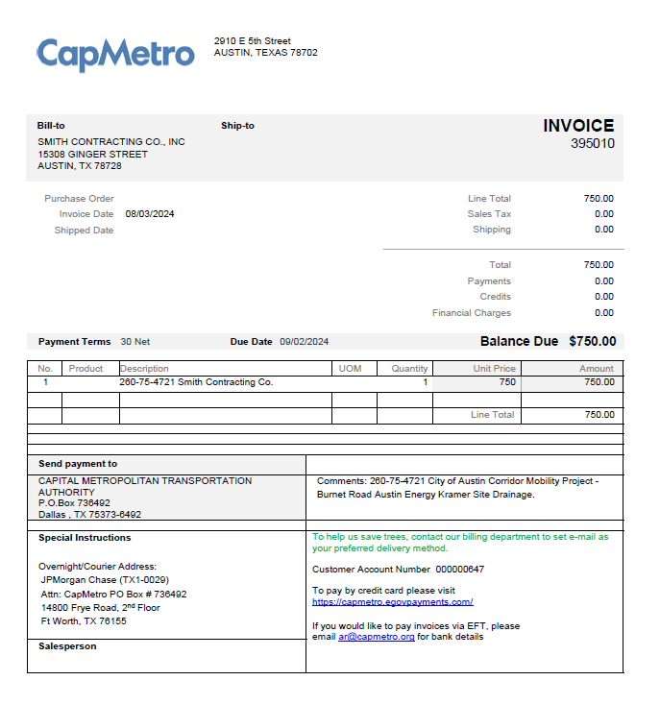

Appendix G
Example of Oracle Generated Report Used to Identify CLS Link Customer Payments

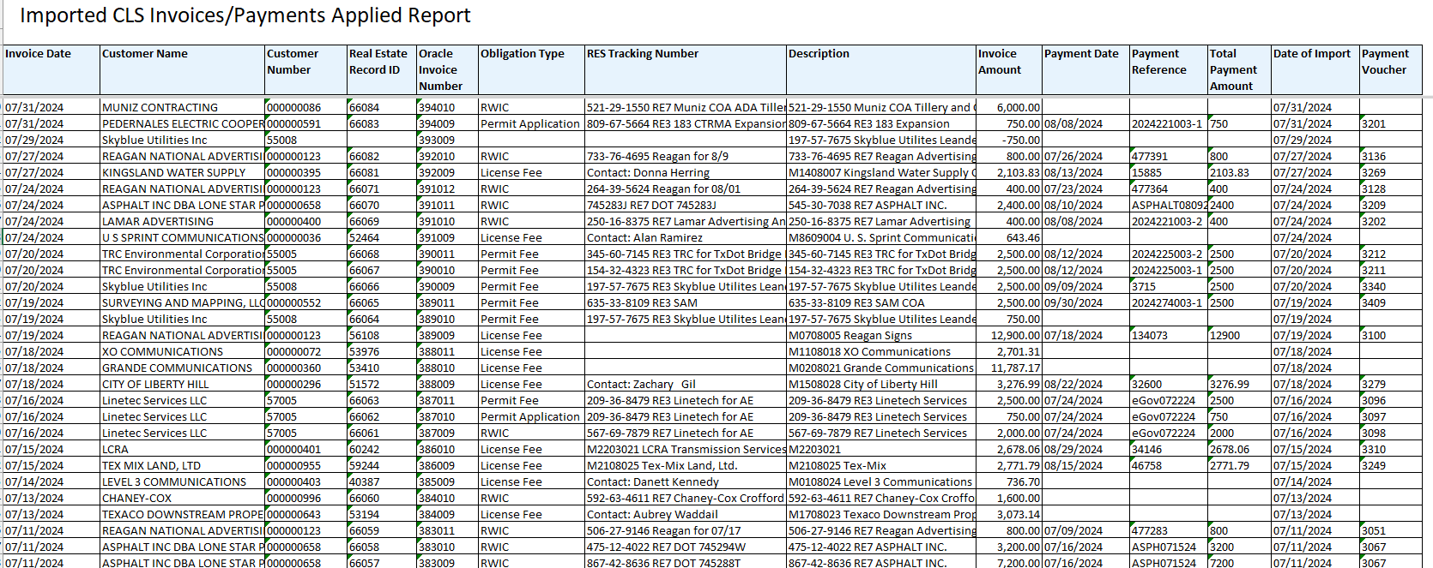

Appendix H

ROW Application and Invoice Statistics

Number of orders for License, Permit, and RWIC (2019-2024)

 | RE1- License | RE3- Permits | RE7 -RWIC | Total
2019 | 28 | 51 | 119 | 198
2020 | 38 | 82 | 229 | 349
2021 | 51 | 76 | 178 | 305
2022 | 42 | 71 | 166 | 279
2023 | 45 | 77 | 141 | 263
2024 (through May) | 20 | 29 | 56 | 105
 | 224 | 386 | 889 | 1499
Source: Platinum Applications (RE1, RE3 & RE7)

Invoices Issued by Type

Billed In Oracle in 2023 | Type | Quantity | Amount
 | License | 266 | $678,480
 | Permit | 73 | $124,300
 | RWIC | 106 | $258,861
Total |  | 445 | $1,061,641
Source: Oracle – CLS Link Imported Invoice/Payment Report

Appendix I

Potential Overbilled RWIC Overtime Hours

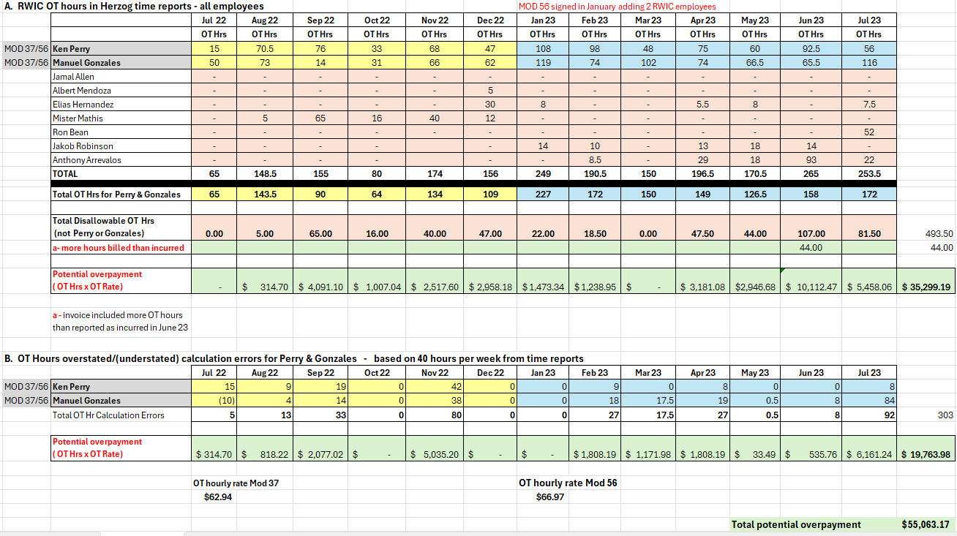

- RWIC Hrs and RWIC OT Hrs Billed were obtained from Herzog Invoice supporting documentation.
- Contract Mod#56 signed in January 2023, allowed approved overtime in excess of 80 RWIC hours for two RWIC employees to be billed at $66.7/hr .
- Using the Herzog invoice support, IA reviewed the weekly Herzog employee time reported to evaluate the overtime calculation.

Appendix J
Herzog Monthly Time Report & Error Examples – July 2023

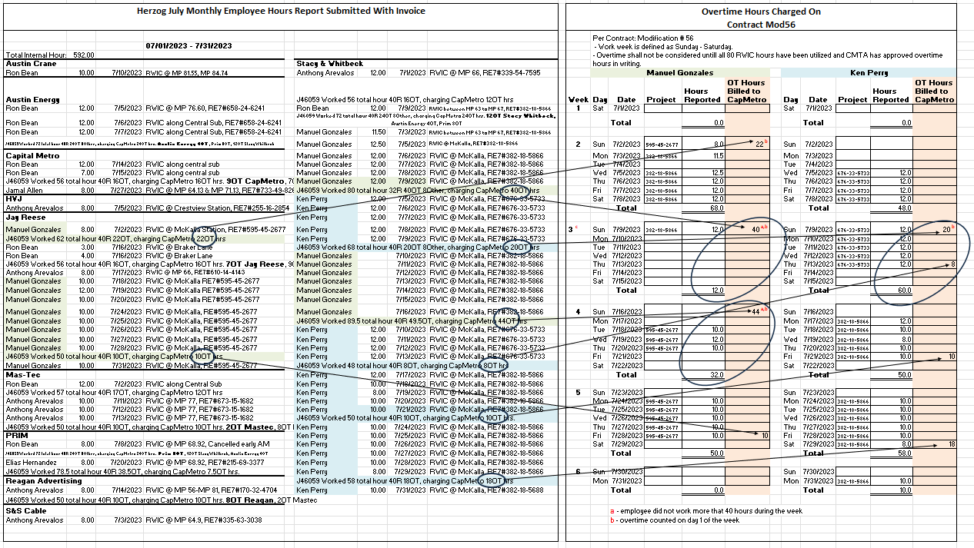

Error Examples
1 – Week 3 – Manual Gonzales worked 12 hours, but 40 OT hours charged
2 – Week 3 – Ken Perry worked 60 hours, but 28 OT hour charged
3 – Week 4 – Manual Gonzales worked 32 hours, but 44 OT hours charged

Appendix K

Herzog July Invoice

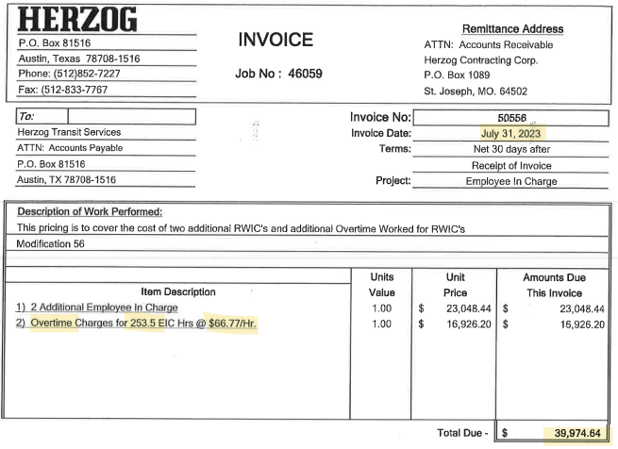

Appendix L

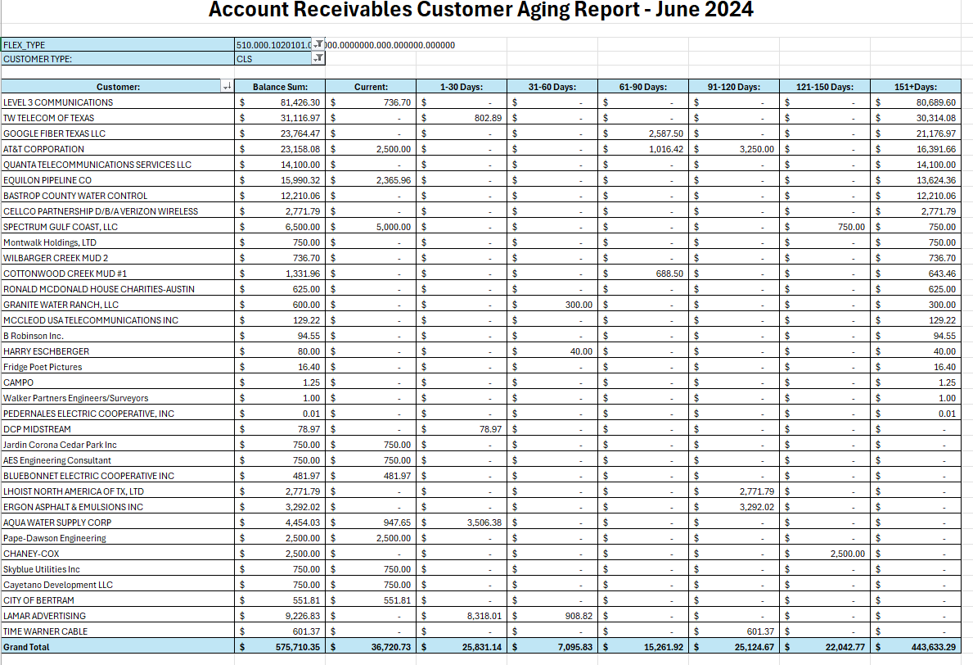

Appendix M
Accounts Receivable Policy FIN 109

