
McKalla Station – Capital Project Controls (24-12)

Terry Follmer, Chief Audit Executive

Distribution List:
Capital Metro Board of Directors
Dottie Watkins, President and CEO
Kerri Butcher, EVP, Deputy CEO
Cheyenne Conyer, Chief of Staff
Donna Simmons, EVP of Administration, Diversity and Inclusion Officer
Sharmila Mukherjee, EVP, Strategic Planning & Development
Gardner Tabon, EVP, Chief Safety Officer
Samantha Baez, EVP, Chief Experience & Engagement Officer
Catherine Walker, EVP, Chief Financial Officer & Risk Officer
Andrew Skabowski, EVP & Chief Operating Officer
Dave Kubicek, EVP, Capital Construction, Engineering & Design
Ken Cartwright, VP, Facility Management & Capital Construction
King Kaul, Director, Capital Construction Management
Vincent Sandoval, Director, Real Estate and ROW
Brian Roybal, Project Manager
Rashmi Vailaya, Director, Project Controls
Susan Mwangi, Manager Transit Asset Management & Inventory
Kevin Conlan, Deputy CFO
Ashley Erickson, VP Organizational Strategy
Becky Gauthier, Director, Enterprise Project Portfolio Management
Nadia Nahvi, Controller
Ben Hodges, Accounting Manager
Christina Palermo, Financial Analyst
Kendra Shelton, Program Manager, Technical Accounting
Robert Moreno, Manager, Internal Audit

Contents
Executive Summary 1

Results ……………………………………………………………………………………………………………………………………………….3
- Real Estate Appraisal Documents Not Obtained for Professional Services
- Construction Capitalization Process
- Capitalization Policies Require Updates and SOPs Are Needed
- Delegations of Authority Not Defined for Temporary Contruction Easement Acquisitions
- Capital Project Funding Source Not Formally Documented

Appendicies 8

- Temporary Construction Easement (TCE) Flowchart for McKalla Station
- Example Introduction Letter and Initial Offer Letter to Landowners
- Example Rescission Letter and Offer Letter to Landowners
- McKalla Station - Temporary Construction Easement (TCE) Parcel Listing
- Excerpt From CPG Policies and Procedures Manual Regarding Funding Sources
- Finance Policy FIN-104 Fixed Assets Capitalization & Disposal Policy
- Finance Policy FIN-105 Capitalization of Labor on Capital Projects

Executive Summary

The fiscal year 2024 Audit Plan approved by the CapMetro Board of Directors included an assurance review of the McKalla Station Capital Project Controls to ensure compliance with contracts, policies, procedures and regulatory requirements. The audit results including the objective, scope and conclusion are as follows.

Background
The McKalla Rail Station is a new regional rail transit station constructed as part of Project Connect to provide increased mobility and transit options for the North Burnet neighborhood. It was a $58.8M capital project of a new rail station located adjacent to Q2 Stadium that opened in February 2024. There were two primary construction projects, McKalla MLS Red Line Station (PLN2103) and McKalla Double Track, Drainage and Signals (PLN2207). The rail station construction was a design-build contract approved by the Board in March 2022 for $16.6M and was awarded to Stacy and Whitbeck. Design-build is a delivery method in which a contractor is responsible for both the design and construction phases to streamline the project. Additional funding approved by the Board brought the rail station total not to exceed $21M. The second project, track and drainage, was approved by the Board in October 2022 not to exceed $29M and was awarded to Jay Reese.

McKalla Station was part of the original Project Connect plan and pursued a variety of funding sources. ATP committed to providing $25M to the project. Q2 also committed $3M over 15 years. The City of Austin provided funding of $750K for betterments, or upgrades, to planned wastewater lines (increased diameter size) and a shared-use path. Initially, there was an expectation that federal funds would be pursued for the McKalla project. CapMetro applied for two federal fund grants, the BUILD 2020 ($11.3M) and INFRA ($17.7M), however, the grant applications were denied in October 2020 and July 2021 respectively. Management informed us that though expenditures on the current project did not qualify for current federal grants, the expenditures could potentially be considered as CapMetro matching fund contributions for future grants if federal standards are followed. The standards applied to projects using federal funds are higher than if only local funds are used. For example, if local funds are used, Chapter 451 of the Texas Transportation Code requires two appraisals for real estate acquisitions. If federal funds are used, the Uniform Relocation Assistance and Real Properties Acquisition Act of 1970 (Uniform Act) requires an appraisal and an additional appraisal review.

The Capital Projects Group (CPG) managed the project, following the guidelines established in their CPG Policies and Procedures Manual and a variety of systems. The core systems used were Planview, eBuilder, Oracle for Accounting and Contract Land Staffing (CLS) which is used for right-of-way licenses, permits and roadway worker in charge (RWIC) fees. Additionally, other departments contributed to the success of the project, for example, the Real Estate Department was responsible for obtaining required permitting, title documents, surveys, and appraisals for temporary construction easements ensuring that contractors had access to the properties along the area where the work was being performed. The Real Estate department engaged multiple contractors to provide technical expertise and management of real estate transactions. The Rail Department was responsible for assigning RWIC, per Federal Railroad Administration and Company policy, to ensure contractor rail safety protocols were followed. Legal Department reviewed contractual documents and Intra-local Agreements.

Audit Objective & Scope
The objective of the audit was to review construction process for compliance with contracts, policies, procedures and regulatory requirements, contract close-out and lien releases. The scope included all invoices for Jay Reese and Stacy & Whitbeck submitted from August 2022 through May 2024 as well as the contract closeout process. We also reviewed other capital project costs charged to the McKalla project to ensure that the process for capital project initiation and capitalization followed CapMetro policies and procedures. We reviewed processes at the initiation of the project such as temporary construction easements acquisition and the contract closeout processes, including and release of retention payments and vendor lien releases.

Opinion
In our opinion, internal controls are generally in place and properly functioning over the capital project processes. We identified some areas where internal controls could be further enhanced as follows:
- Real Estate Appraisal Documentation Not Obtained for Professional Services
- Construction Capitalization Process
- Capitalization Policies Require Updates and SOPs Are Needed
- Delegations of Authority Not Defined for Temporary Construction Easement Acquisitions
- Capital Projects Funding Source Not Formally Documented

More details regarding the issues/risks and recommendations can be found below in the detailed audit report.

This audit was conducted in accordance with US Government Accountability Office’s Generally Accepted Government Auditing Standards (GAGAS) and the Institute of Internal Auditor’s International Standards for the Professional Practice of Internal Auditing. These standards require that we plan and perform the audit to obtain sufficient, appropriate evidence to provide a reasonable basis for our findings and conclusions based on our audit objective. We believe the evidence obtained provides a reasonable basis for our findings and conclusions based on our audit objectives. The audit was conducted by the following staff members in the Capital Metro Internal Audit Department:
- Robert Moreno, Manager of Internal Audit
- Terry Follmer, Chief Audit Executive

Recommendations to strengthen controls and improve accountability were provided to management. Management agrees with the internal audit recommendations and has provided target completion dates which are included in the detailed audit report below. A follow-up audit is performed semi-annually (i.e., May and November) to ensure management action plans for all issued audit reports are completed in a timely manner.

We appreciate the cooperation and assistance provided to us throughout this audit.

Audit Report

Issues & Risk | Recommendation | Management Action Plan
- REAL ESTATE APPRAISAL DOCUMENTS NOT OBTAINED FOR PROFESSIONAL SERVICES  CapMetro identified 14 property parcels to be considered for potential temporary construction easements (TCE) for the McKalla project. FTA requires an appraisal and an independent review of the appraisal while state regulations require two appraisals on each property to ensure fair market value is established. Appraisals and surveys totaling over $300K were performed for the 14 parcels. Ultimately only three of the 14 parcels needed a TCE to be purchased. See Appendix A for TCE flowchart, Appendix B & C for examples of letters to landowners and Appendix D for TCE parcels identified.  We requested copies of the appraisal documentation from the Real Estate department, but the documentation was not available. The completed appraisal documents had not been uploaded to CapMetro SharePoint site but were retained by HDR Engineering.  The Real Estate department subsequently obtained the documents. Upon review of the documents, we noted that some parcel documentation (i.e. second appraisal or appraisal reviews) was missing from the documents provided.  Lack of documentation of work performed, reduces management’s ability to:  a) Effectively review and approve contractor invoices, and  b) Ensure complete and accurate records are maintained for CapMetro and for potential future federal grants. | Internal Audit recommends that Management implement the following:  - The Director of Real Estate and ROW should consider implementing a process to obtain all work product from vendors before approving invoices to ensure that the service is complete, accurate and saved to SharePoint.  - The Director of Capital Construction Management should consider defining the responsibility for managing real estate project documentation to the Director of Real Estate and ROW within the Capital Project Group Procedures and Policy Manual. | Management agrees and has developed the action plan below.  - The Director of Real Estate and ROW will update the Task Order Status spreadsheet to include tracking receipt and SharePoint update of professional service deliverables.  - The Director of Capital Construction Management will update the Capital Project Group Procedures and Policy manual.  Target Completion Date:  December 31, 2024
- CONSTRUCTION CAPITALIZATION PROCESS  McKalla Station was a $58.8M construction project that went live in February 2024 and final payments were made to vendors in May 2024. As of September 30, 2024, the related assets had not been recorded in the Oracle ERP and Hexagon EAM systems, and the two systems had not been reconciled.  We reviewed the construction capitalization controls used to update the Oracle and Hexagon systems and identified the following weaknesses:  - There is FIN-104, Fixed Asset Capitalization & Disposal Policy (Appendix F), however there is no SOP detailing procedures for Accounting and Capital Project Group (CPG) staff as to how/when construction is to be capitalized and recorded into the Hexagon and Oracle systems.  - There are no training or periodic meetings between CPG and Accounting to discuss construction status and capitalization process.  - The monthly PlanView Upcoming Go-Live project report has project percentage of completion from budget, but it is missing the percentage of actual project completion.  - Required reports and reporting procedures between CPG and Finance have not been defined.  The situations above increase the risk that assets may not be capitalized timely and assets between Hexagon and Oracle cannot be reconciled. | Internal Audit recommends that the Controller and the VP of Facilities Management & Capital Construction should consider the following improvements:  - Define and develop SOPs for construction processes to ensure CPG and Accounting Departments are getting timely and appropriate information to ensure capitalization records in both Hexagon and Oracle systems can be properly updated. From here, develop Policies and SOP’s that codify the process and ensure appropriate staff within CPG and Accounting are trained and understand how their activities support each other.  - Periodic meetings (e.g. monthly and/or quarterly) should be scheduled between CPG and Accounting to ensure proper communications and coordination of projects.  - The monthly PlanView Upcoming Go-Live report should be updated to include a field that captures the actual project percentage of completion.  - Capitalized assets in Hexagon should be reconciled to Oracle asset records monthly. Any unexpected differences should be investigated and adjusted in Hexagon and/or Oracle. | Management agrees and has developed the action plan below.  a. Capital Projects Group and Finance will develop SOPs for documenting and recording fixed assets in the respective Hexagon and Oracle systems. After the SOPs have been created, the policies will be developed that incorporate the SOP.  b. Capital Projects and Accounting have initiated monthly meetings in October to discuss project activity.  c. Enterprise Project Portfolio Management group is developing a process workflow in Planview which would include an approval by both Accounting and Capital Projects before a project can be advanced from the “Execute” status to the “Close” status.  d. Accounting has begun reconciling Oracle capital assets to Hexagon assets. As Oracle asset numbers are created, the information will be forwarded to Capital Projects to add to the asset in the Hexagon system as a cross reference.  Target Completion Date:  June 30, 2025
- CAPITALIZATION POLICIES REQUIRE UPDATES AND SOPs ARE NEEDED  There are two Finance policies related to capitalization of assets, FIN-104 Fixed Asset Capitalization and Disposal Policy (See Appendix F) and FIN-105 Capitalization of Labor on Capital Projects (See Appendix G). We noted the following issues with the polices:  - Policy FIN-104 was last updated in October 2019 and references the prior Fixed Asset accounting module from the Microsoft Dynamics AX system. Policy FIN-105 was last updated in 2013 and includes hyperlinks to forms FN11 Capital Labor Hours Log (Employee) and FN12 Capital Labor Hours Log (Project Manager). However, the hyperlinks to these forms are broken and it appears the documents have been renamed as FIN9 and FIN10 respectively.  - Neither policy FIN-104 nor FIN-105 define which accounting standards they follow, for example US GASB or other Federal guidelines or FTA requirements.  - FIN104 provides a brief description of Construction Work In Progress (CWIP) but does not elaborate on any specifics. There are no SOPs to provide further instructions on the CWIP process. Additionally, there are no SOPs for FIN-105.  - There are three manual forms used in the fixed asset documentation process. FIN2 Property Acquisition Form, FIN5 Property Disposal Form, and FIN6 Property Transfer Form each include a field from the previous EAM system titled SPEAR ID #. | Internal Audit recommends that the Controller consider the following improvements:  - Updating FIN-104 and FIN-105 to reflect current accounting requirements, practices, and document form hyperlinks. The policy should include basic definitions of assets to guide users outside the Finance department. Instructions should be communicated with other departments to ensure that all parties are aware of and understand the requirements.  - Identify and document the relevant accounting standards to be used and incorporated into the Finance policies.  - Develop SOPs and procedures documents for the capitalization process which will define the expectations for all parties to follow to ensure items are properly categorized.  - Determine whether the forms (FIN2, FIN5, FIN6) are still necessary for documenting assets and if so, update the fixed assets forms to correspond to the current Hexagon EAM fixed assets system. | Management agrees and has developed the action plan below.  Finance will develop SOPs for fixed asset capitalization during this process, the fixed asset policies and forms will be updated to correspond.  Target Completion Date:  June 30, 2025
- DELEGATIONS OF AUTHORITY NOT DEFINED FOR TEMPORARY CONSTRUCTION EASEMENT ACQUISITIONS  The Capital Projects Group Policies & Procedures Manual references Board approval for real estate transactions over $150K. The Procurement Policy & Procedures documents the approval process for various procurement transactions; however, real estate transactions are excluded. Real estate transactions are unique and highly subjective. Management has not defined delegations of authority to specify approvals for various real estate transaction types less than $150K.  CapMetro acquired three Temporary Construction Easements (TCE) for the McKalla project. We identified a transaction for the acquisition of a property in which the higher of two appraisals indicated a market value of $20K. However, the landowner made a counteroffer of $30K, 50% over the appraised market value, which was accepted by CapMetro to keep project construction moving forward. There is no policy to define who can approve TCE or transactions that may be above appraised market value.  Without pre-defined authority limits for property acquisitions, there is a potential that unreasonable or unauthorized amounts could be paid to acquire temporary construction easements. | Internal Audit recommends that the VP, Facility Management & Capital Construction should work with the Legal Department to develop acceptable approval limits for routine and exception transactions (e.g. paying more than appraised value) within the overall CapMetro delegations of authority approval matrix. | Management agrees and has developed the action plan below.  VP, Facility Management and Capital Construction will obtain clarification from Legal regarding the Delegation of Authority. If the delegation needs to be revised, the VP will pursue it with Legal.  Target Completion Date:  December 31, 2024
- CAPITAL PROJECT FUNDING SOURCES NOT FORMALLY DOCUMENTED  CapMetro Management determines whether the Agency will pursue federal funds. Any use of federal funds triggers the requirement to follow the Uniform Relocation Assistance and Real Properties Acquisition Act of 1970 (Uniform Act). The CapMetro Capital Projects Group Policy and Procedures Manual acknowledges that the use of federal funds necessitates special procedures are to be followed. See Appendix E for Excerpt from Manual.  However, there is no notation in the policy manual that specifies that capital projects should be identified by the expected funding source to be pursued as it will affect the process flow needed for that project (e.g. if and how many appraisals are needed).  Inadequate or ambiguous communication of the funding source could cause unnecessary spending to occur if higher than necessary federal standards are followed. Conversely, if the higher standards are not followed when required, it may restrict the ability to obtain federal funding. | Internal Audit recommends that the Capital Projects VP should consider developing procedures to include the anticipated funding source to be used in project documentation such as the Project Charter. | Management agrees and has developed the action plan below.  Project Managers will document the funding source in the Project Charter.  Target Completion Date:  December 31, 2024

Appendix A

Temporary Construction Easement (TCE) Flowchart for McKalla Station

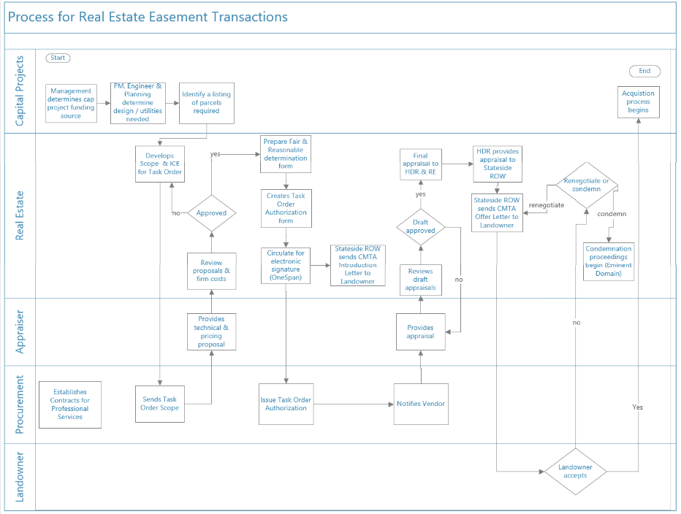

Appendix B

Example Introduction Letter and Initial Offer Letter to Landowners

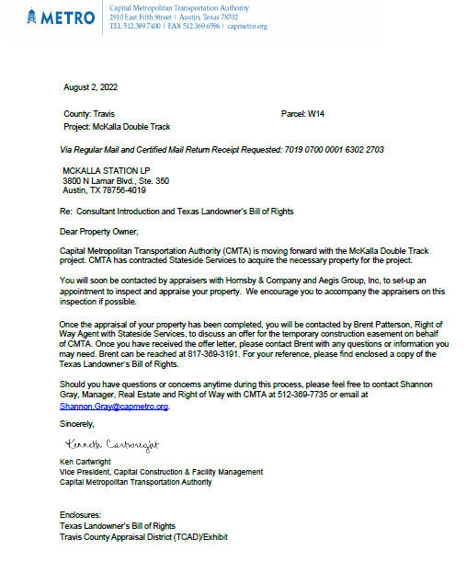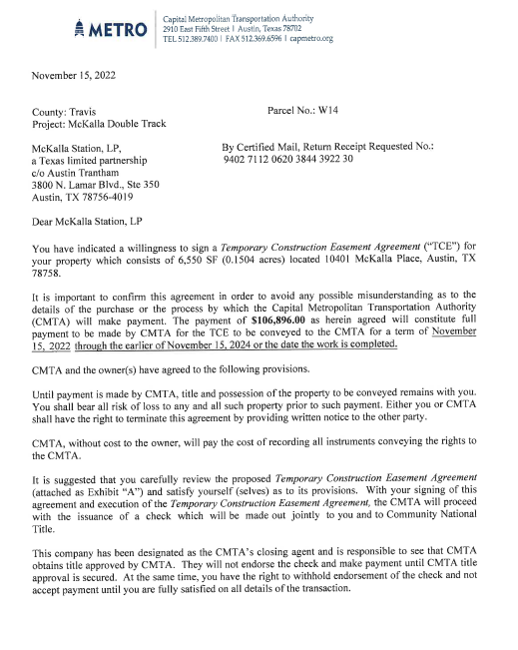

Appendix C
Example Rescission Letter and Offer Letter to Landowners

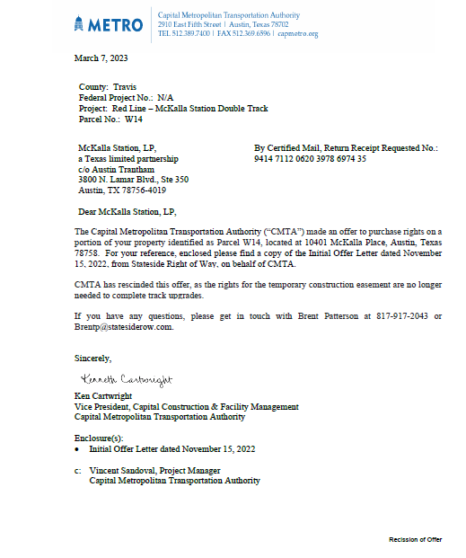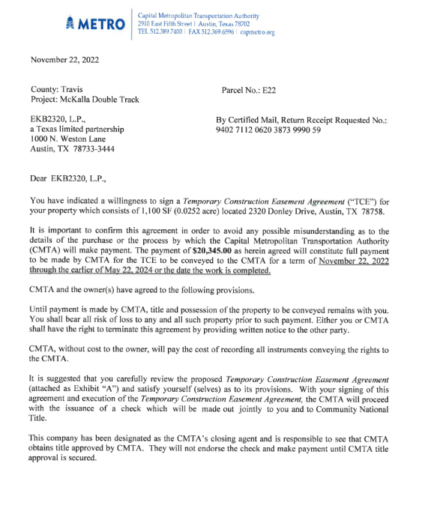

Appendix D
McKalla Station - Temporary Construction Easement (TCE) Parcel Listing

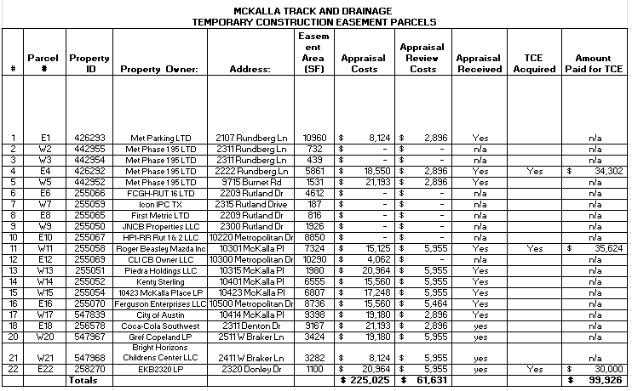

Appendix E

Excerpt from CPG Policies and Procedure Manual Regarding Funding Sources

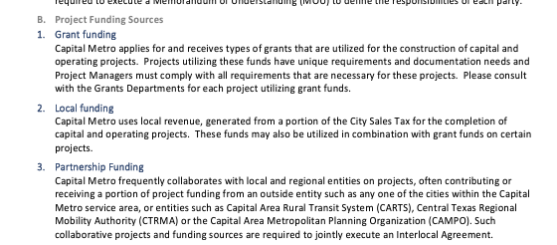

Appendix F pg1

Finance Policy FIN-104 Fixed Assets Capitalization & Disposal Policy

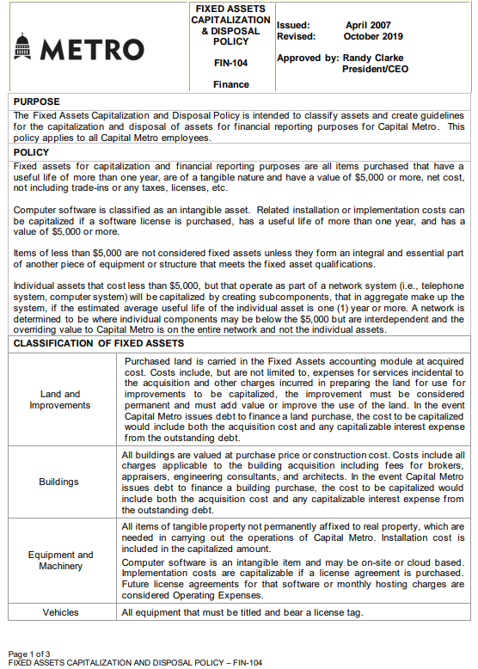

Appendix F pg2

Finance Policy FIN-104 Fixed Assets Capitalization & Disposal Policy - continued

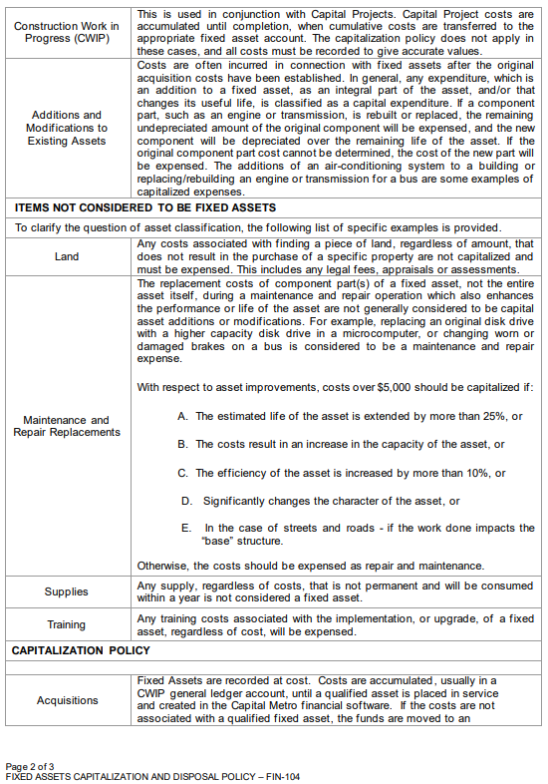

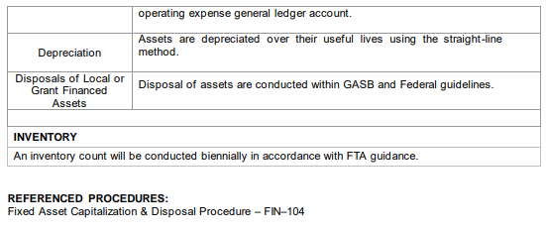

Appendix G

Finance Policy FIN-105 Capitalization of Labor on Capital Projects

